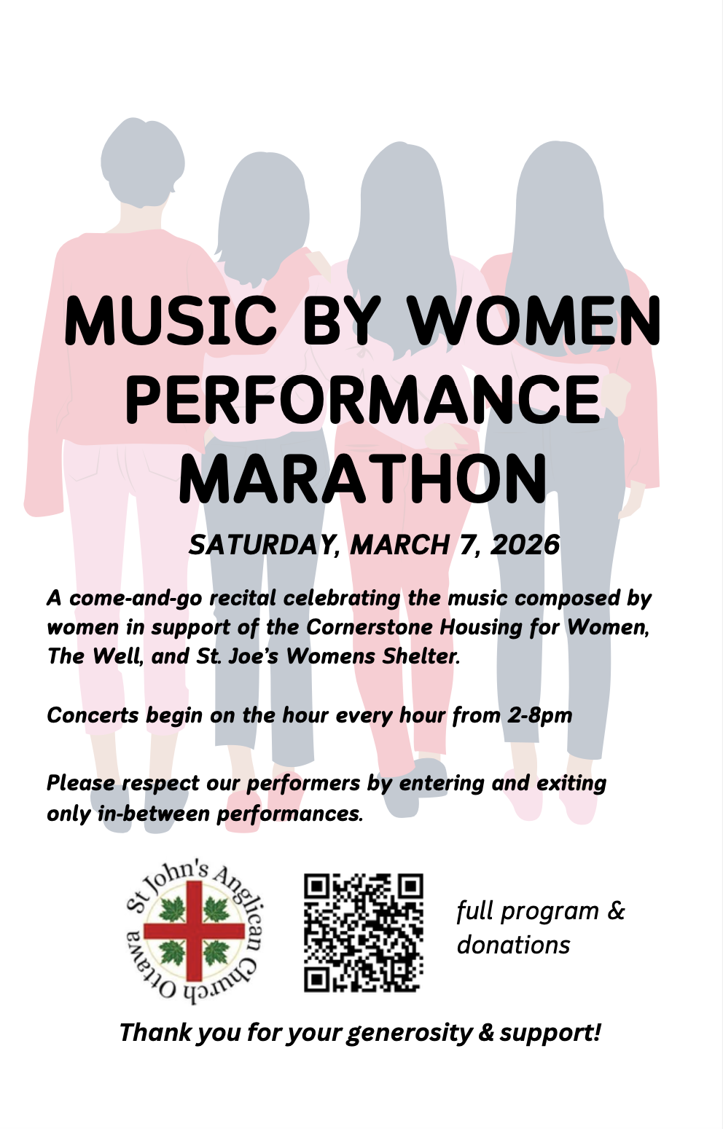

Complete Programme
2pm Concert – Poetry & Piano
Welcome & Opening Remarks
Robert Hall, piano
Four Spirituals:
Be Still, My Soul arr. Ruth Elaine Schram
I Want Jesus arr. Mary McDonald
All-Night, All-Day arr. Ruth Elaine Schram
Joshua Fit the Battle arr. Mary McDonald

Mary Lou van Schaik, poetry
Selections from "Forge" by Jan Zwicky

Françoise Slaunwhite, piano and voice
Début by Mélanie Laurent
Moonrise by Michele McLaughlin
Cherish by Rebecca Kaiserin
Les Filles Montagnes by Viviane Audet
come into my arms by November Ultra
Today I Dreamed a Dream for You by Emily Hall

Diane Perazzo, poetry
Selection from a project called "Sowing the Future" (www.sowingthefuture.ca)

3pm Concert – Student Musicians & Community Musicians

Lili Savoie, piano
Around Again by Katya Pine
Flying Ravens by Thelma Gillis

Vera Zakaluzny & Jamie Liew, piano
Na Mnohee Leeta arr. Laureen Kells
Let's Go Riding by Jen Smith Lanthier

Elliot Donahue, piano
Bones, Bones, Old Bones by Rebekah Maxner
Gentle Panda by Lynette Sawatsky

Amanda Hennelly, voice & Olivia Adams, piano
Remember her name by Mickey Guyton

Elizabeth Smith, voice & Olivia Adams, piano
Wildflowers by Billie Eilish

Lucía Solano-Rivers, voice, & Megan Rivers-Moore, piano
Love in the Dark by Jessie Reyez

Kristina Heatley, voice & guitar
Still rolling stones by Lauren Daigle
Thank God I do by Lauren Daigle

Citlali Cervantes Garcia, voice, guitar, & piano
Every Part of Me by Citlali Cervantes Garcia
Guardian Angel by Citlali Cervantes Garcia

Angélique Levac, piano
The Jack Pine by Jocelyn Morlock

4pm Concert – Choirs & Small Ensembles
All Voices Community Choir Junior Voices, conducted by Linda Crawford
The Sun is Mine by Laura Hawley
The Squirrel by Laura Hawley
Carry the Music by Sarah Quartel

Vocal Trio – Kristina Heatley, Seun Alabi & Citlali Cervantes Garcia
Ride the Waves by Citlali Cervantes

All Voices Community Choir Adult Voices, conducted by Linda Crawford
Warrior by Kim Baryluk, arr. Blackwood
If I Could Sing You Well by Stephanie Martin
Frobisher Bay/Northwest Passage by James Gordon, Stan Rogers; arr. Sarah Burnell

The Bold Voices of Ottawa, conducted by L.E. Bolden
Roots by B. E. Boykin
City Called Heaven by Josephine Poelintz

5pm Concert – Strings & Piano
Ottawa Youth Orchestra Academy Junior Strings, conducted by Caren Abramoff
Arirang: traditional Korean folksong, arr. Deborah Baker Monday
Battle by Soon Hee Newbold

Edith Hartshorn-Walton, piano
Left Alone by Joyce Grill
The Sleeping Dragon by Nancy Telfer

Auréa Hartshorn-Walton, piano
River City Blues by Martha Miers
Spanish by Agatha Bracker Grøndahl

Olivia Kwan, Adele Ferguson, Edison Li & Logan Kwan, string quartet
Sweet New Moon by Yukiko Nishimura
Adoration by Florence Price
Sonata no. 4 by Magdalena Lombardini-Sirmen

Elly Li, Benjamin McDermott, Amelia Whitwill, violin trio and Caren Abramoff, piano
Anneke's March by Carolyn Hatch
Beyond the Thunder by Deborah Baker Monday

Bingsen Feng, violin & Caren Abramoff, piano
Mazurka by Natalya Vladimirovna Baklanova

Nolan Barth, Liam Gu & Allan Millner, string trio
Tops and Tails by Sheila Nelson
Train to Truro by Sheila Nelson
Ostrich Waltz by Sheila Nelson

Sofia El-Chaar, harp
Winter Still by Sharlene Wallace

Mary Muckle, harp
Silence and Love by Mary Muckle
Kathleen Na Geara by Mary Muckle

6pm Concert - Community Musicians & Poetry Recitations
Oddeline, voice and piano
Waiting by Marianne Keuleman
Run by Marianne Keuleman

Ellen Lee, poetry
“A deeper shade of Jade” by Ellen Lee

Krisha Séguin, voice and Nicholas Busch, piano
Ich stand in dunklen Träumen by Clara Schumann

Denis Séguin, voice and Nicholas Busch, piano
Chanson de Neige by Cécile Chaminade

Serena Sullivan, violin
I Can Finally Feel the Sun by Carmen Braden

Daryl Banke, poetry
Freedom Flight by Sylvia Banke, Dec 30, 1973

Jen Nunley, soprano and Nicholas Busch, piano
“I’m Nobody” from Four Dickinson Songs by Lori Laitman, text by Emily Dickinson

Brandon Vrooman, piano
Berceuse by Dana Suesse

Adèle Finlayson, poetry
“To Be of Use” by Marge Piercy
“Dirge Without Music” by Edna St. Vincent Millay
“Stabat Mater” by Adèle Finlayson
“Prayer of the Arisen” by Adèle Finlayson
“Essence” by Adèle Finlayson
“Bises et Baisers” by Adèle Finlayson
“The Voyage” by Adèle Finlayson
“Sonnet in C” by Adèle Finlayson

Olivia Adams, piano
Clavierstuck V by Melika M. Fitzhugh
Reverie by Alexandra Stréliski

7pm Concert – Community Musicians
Opening remarks – Nicholas Busch, Director of music at St. Johns
Anika-France Forget, voice and piano & Rawan Ismail, voice
The Road Unknown by Anika-France Forget, text by Walt Whitman
I Will Whisper Your Name by Anika-France Forget, text by Aude A. Saint-Laurent
Imaginer l'amour by Juliette Armanet

Nisreen Jardaneh – piano and tongue drum
Pipa Language by April Yang
Medley on steel tongue drum by Nisreen Jardaneh
Bint El Shalabieh (The Beautiful Girl) by Fairuz

Olivia Adams, piano
Borders by Alexandra Stréliski
Nurture by Cait Nishimura

Melika M. Fitzhugh, piano
Clavierstuck XVI: Visitation by a Raven by Melika M. Fitzhugh
The Wound at the End of My Silence by Melika M. Fitzhugh

Carolyn Streich, soprano and Nicholas Busch, piano
Eliza Aria by Elena Kats-Chernin

Josée Landry, soprano and Nicholas Busch, piano
From Opus 13 by Clara Schumann
Ich stand in dunklen Träumen
Sie liebten sich Beide
From Opus 23 by Clara Schumann
An einem lichten Morgen

Mark Wilkinson, baritone and Nicholas Busch, piano
Liebst du um Schönheit by Clara Schumann
Narrow Daylight by Diana Krall

Closing remarks – Olivia Adams, event organiser
Alice Yu Shen Li, piano
Selections from Romances sans paroles, Op. 76 by Cécile Chaminade

This event would not be possible without the generous support of our host, St. John the Evangelist and their music director, Nicholas Busch. Thank you to the incredible team of volunteers: Mikayla Odout, our stage manager and Melika Fitzhugh for program design. Thanks to our donation table volunteers and ushers: Christine Allman, Amanda Hennelly Bridget Nardi, Maria Judd, Emy Verdun, Erin Morrison and Sam Sloan. Thank you to our stagehand, Katarina Jovic. Thank you to each and every one of the 145 musicians involved in making this event happen. Thank you to our audience for their kind and generous contributions through donations and presence. We will see you in 2028!

Performer Biographies

Olivia Adams is a pianist, researcher, and music educator. She serves as the Director of Education at the Lotus Centre for Special Music Education. She is a Ph.D. candidate at the University of Ottawa, where she researches accommodations in music performances for neurodivergent musicians. She is the author of Loud and Clear: A Guide to Levelled Piano Music by Women Composers in the 20th and 21st Centuries, and is the proud organizer of this event.

The All Voices Community Choir is a non-auditioned, inclusive choir with 3 ensembles: Children, Teens and Adults. They rehearse on Wednesday, in Kanata, and new singers are welcome to join in September, or in January. Speak to LInda or Nick today, or visit allvoicescc.ca for information. They will be singing 2 all-Canadian concerts in May: join them for a Canadian musical feast!

The Bold Voices of Ottawa is a new community choir that performs music exclusively written and arranged by Black composers!

Nicholas Busch received a MMus specializing in Collaborative Piano from Western University, and is an Associate of the Royal Canadian College of Organists. He currently holds the position of Director of Music at St. John the Evangelist Anglican Church.

A native of Stafford, Virginia, Melika M. Fitzhugh (A.B. Harvard-Radcliffe, M.M. Longy School of Music) studied composition with Roger Marsh, Jeff Stadelman, and, most recently, John Howell Morrison. Performed internationally, Mel is a film/stage composer who enjoys writing new music for historical instruments, and is currently a member of world/early music ensembles Urban Myth, Balkan Fields, and the Quilisma Consort.

Anika-France Forget is a French-Canadian mezzo-soprano and composer whose works have been heard across Canada, the United States, France, and the UK. Rawan Ismail is a Canadian soprano with international stage experience. Joining forces as a duo for the first time, they both teach voice and piano at The Bird & The Bean Music Studio in Alta Vista.

Robert Hall taught music at Laurentian University in Sudbury for over 25 years. Since retiring and moving to Ottawa he has had church appointments at City View United Church and St. Matthew's Anglican Church.

Auréa Hartshorn-Walton is a grade 9 student at De La Salle. She studies piano with Cecile Desrosiers and Harp with Caroline Leonardelli. She is a proud member of the ByTown Voices. In her spare time, she plays drums, swims, and loves skateboarding.

Edith Hartshorn-Walton is a grade 7 student atDe La Salle. She studies piano with Cecile Desrosiers and violin with Cendrine Despax. Edith also sings with Ottawa's ByTown voices. She spends her free time reading and being social.

Josée Landry is a soprano with a BMus from Western University and a MMus from the University of Ottawa. She is always happy to make music in the Ottawa community, whether it be singing in an opera, as a soprano soloist, or a chorister.

Ellen Lee is an interior designer, artist, creator, cyclist, all around multi-faceted woman collecting joy through connective experiences.

Mary Muckle is a Canadian harpist, composer and teacher living in Ottawa. Her compositions and arrangements for harp solo, harps in ensemble and voice with harp accompaniment are published by Afghan Press, Houston, Texas. Among her publications for solo harp are "Silence and Love" and "Kathleen Na Geara."

Jen Nunley (they/them) is lifelong performer who earned a master of music from Lee University in 2013. They immigrated to Canada with their partner in 2021. Jen enjoys taking voice lessons and singing alto in St. John’s choir.

Known for weaving dreamy vintage sounds into thoughtful, carefully crafted songs, Oddeline is a musical project based in Ottawa, Ontario. Her style is heavily influenced by 1960s jazz-folk like Nick Drake and Fairport Convention, with a DIY attitude rooted in a love of post punk and early indie bands.

Diane Perazzo is a poet, legacy writing facilitator and eco witch. She is a co-creator of the art and poetry exhibit Sowing the Future: When Food Becomes Connection and author of several chapbooks. Her poems have been published in a variety of earth-based spirituality and ecology-focused publications. More info: www.dianeperazzo.com

For the past 15 years, Poetry Troubadour Mary Lou van Schaik has shared the vibrancy of spoken poetry with groups and individuals. She has performed in concerts with other poem speakers and musicians, and hosts a monthly online poem sharing circle.

Françoise Slaunwhite has loved music her whole life and seized the opportunity to learn to sing and play the piano as an adult. She gravitates towards contemporary dreamy pieces and lyrical songs. Françoise also enjoys collaborating with other musicians and sharing music in a variety of community settings.

Carolyn Streich is a soprano soloist for the church choir at St. John's the Evangelist. She has a Bachelor of Music in Voice Performance, and enjoys singing classical and music theatre styles. Beyond her musical pursuits, Carolyn has a career in mental health as a Registered Psychotherapist.

Serena Sullivan is a violin performer and teacher from Edmonton, Alberta. She is currently pursuing her Bachelor of Music at the University of Alberta.

Nisreen Jardeneh is a piano teacher in Orleans committed to fostering connection, creativity, and well-being through music. She wrote My Music Concert, a story designed to help students get ready for their performances. Her debut album, "Mediative Tunes in Nature," features the soothing sounds of the steel tongue drum.

Canadian baritone Mark Wilkinson calls Ottawa home while performing on stages and in concert halls throughout North America and Europe. Having been heard and seen on the CBC-SRC numerous times and given multiple world premieres, he relishes bringing these experiences to Ottawa for each new collaboration at home. He is an Artist-in-Residence here at St. John's.

Alice Yu Shen Li is a pianist from Saskatoon, SK, dedicated to classical and contemporary repertoire, with a focus on female composers. She has earned national recognition and performed across Canada and Europe, with recent engagements with the Saskatoon Symphony Orchestra and Orchestra Kingston. She is currently a third-year medical student at Queen’s University.

